Points for quality w/s.

1 Required an IMPORT item master for header entry.

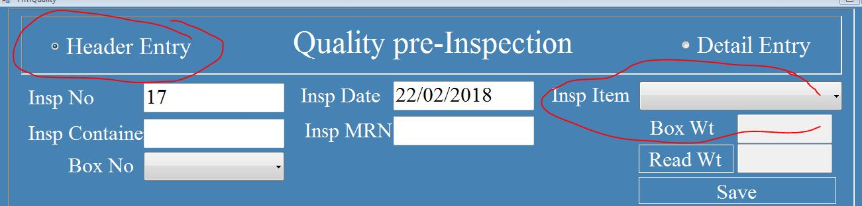

2 Required a weight % of final item on quality sample final inspection window.

3 complete bouton required on quality sample final inspection window.

4 Time limitation is not required. After complete bouton, header entry data not show.

5 Bouton should be complete by HOD.

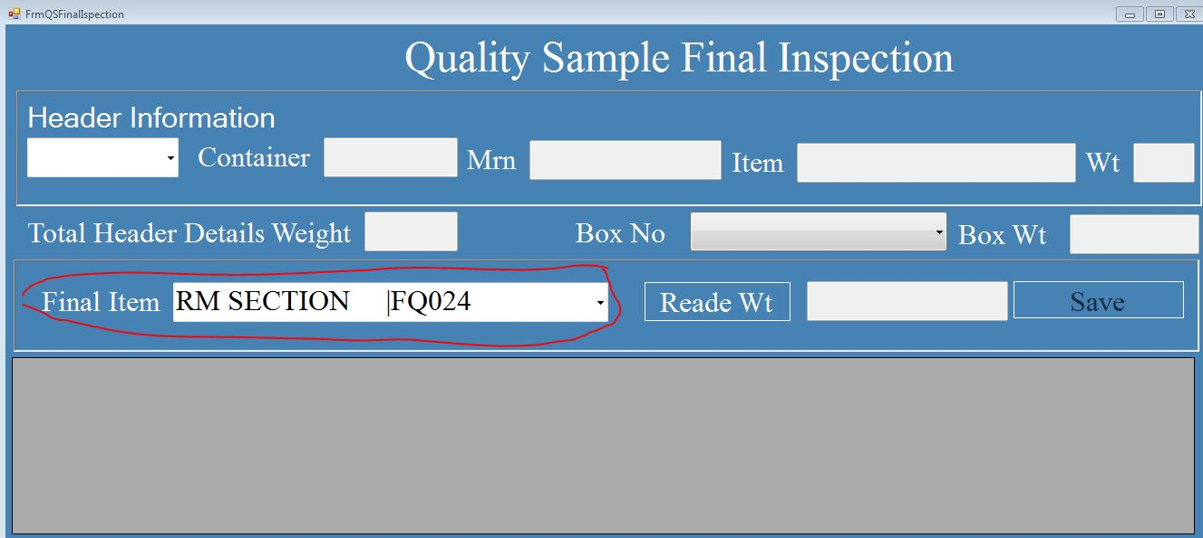

6 During a final item weight, if operator save same item two or three times, then same item name save in pervious save data and wt. quantity is increase of pervious save data of same item name , not create one other transaction line of same item name.

C:\Users\support2\Desktop\same item add in one item.JPG

C:\Users\support2\Desktop\same item add.JPG

Above same item example.

Ram cast =70

Ram cast =141

Ram cast =141+70 =211 required this.

7 contain change. Total Header Details weight =Total attach item weight.

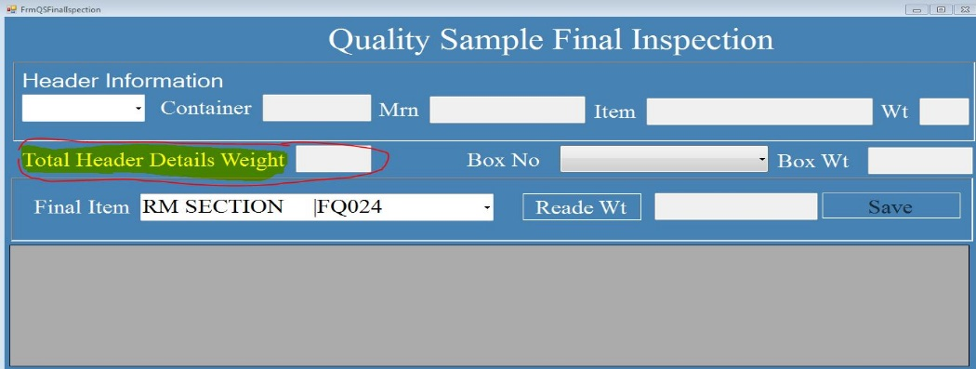

8 Quality report following requirements.

1. Total wt. and percentage required in final report.
2. Attach item reports with % and total wt.
3. When import a final report in excel then, I calculate total % of finial item and % should be 100% of addition of final item %.

Note % required both location w/s form and report.